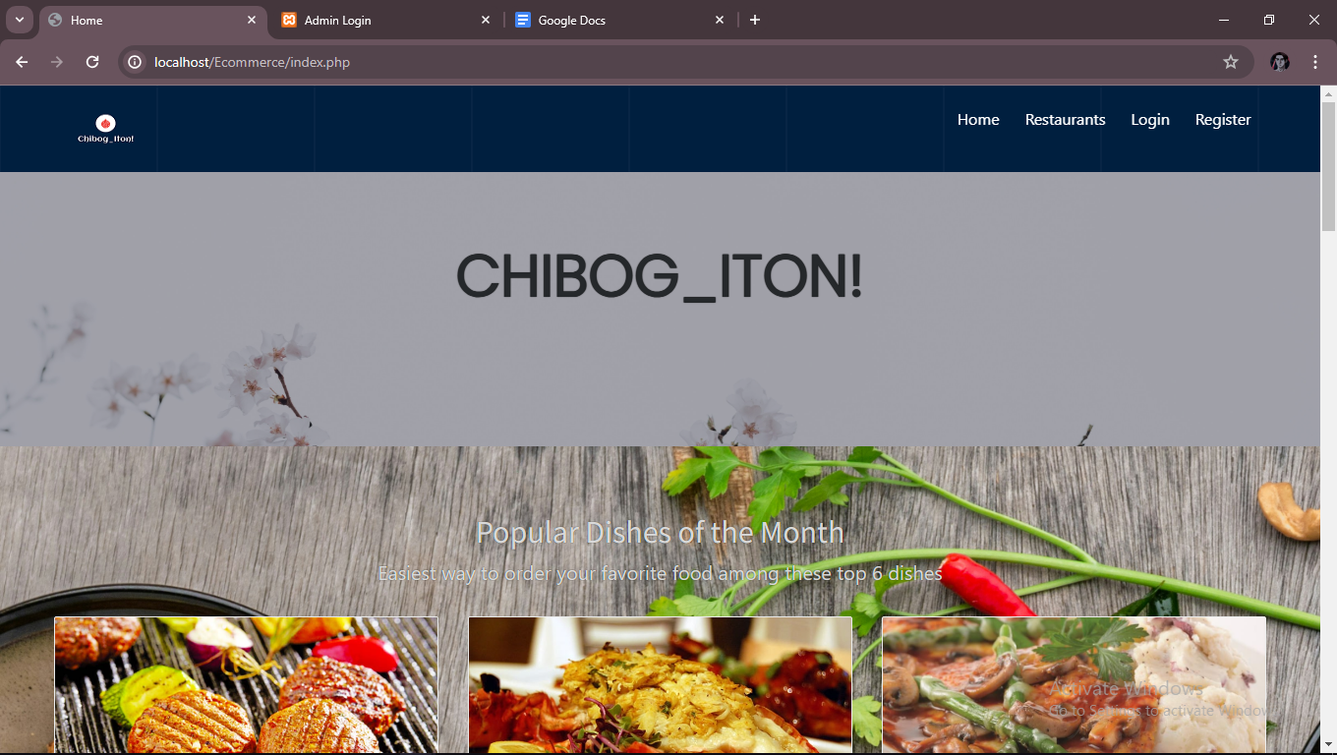

This is our interface the name of our e-commerce site is locator at the top of the body of the page then under it is our popular dish of the month for now it’s not dynamically changing, we just based on the frequently ordered by our customers.

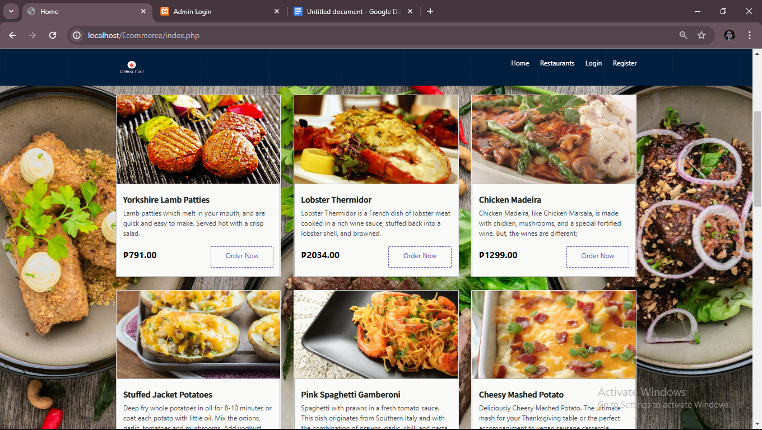

Here is a better view of the popular dishes and you can directly order when you press the order now button  
  
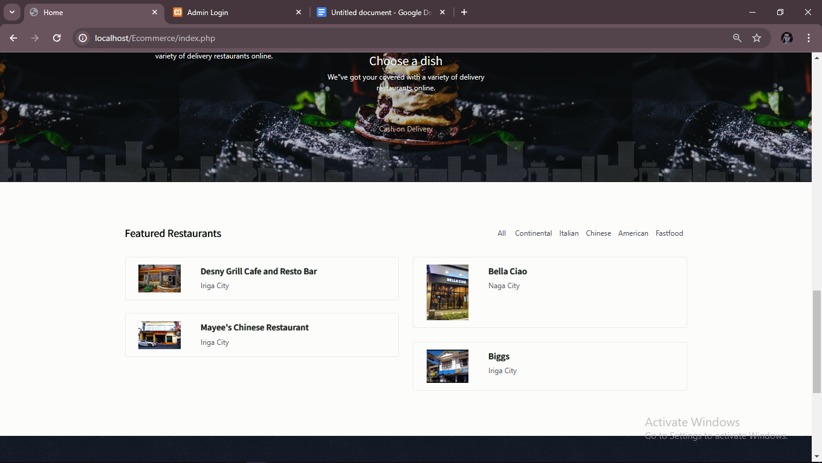

And if you scroll down you will see the featured restaurants that the customer frequently orders.

Same as the dishes if you press one of the featured restaurants it will redirect you to the whole menu of the restaurants serves and you can add to cart some of the dishes and see the price and also you can see the address of the restaurants.

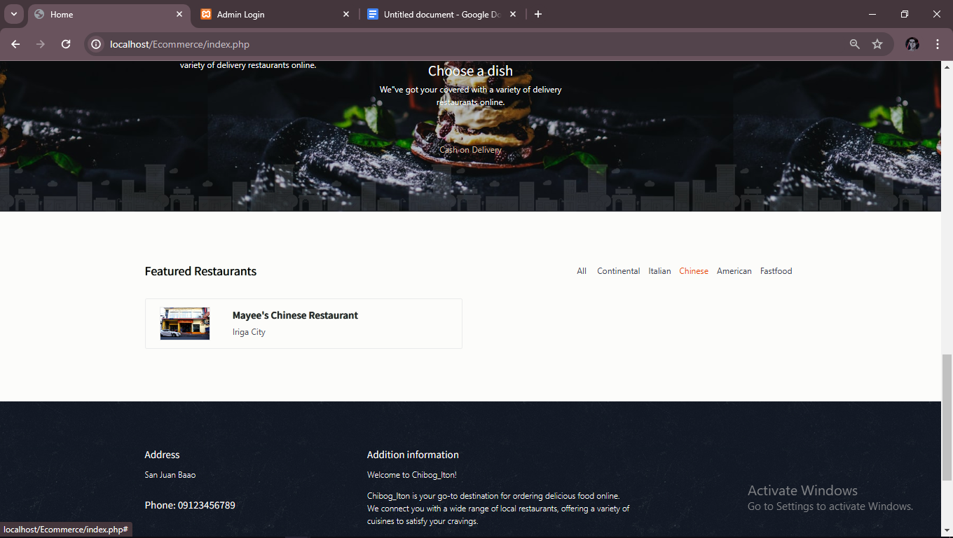

And also there’s a sorting of category of restaurants so that you can select either chinese restaurants, italian or american.

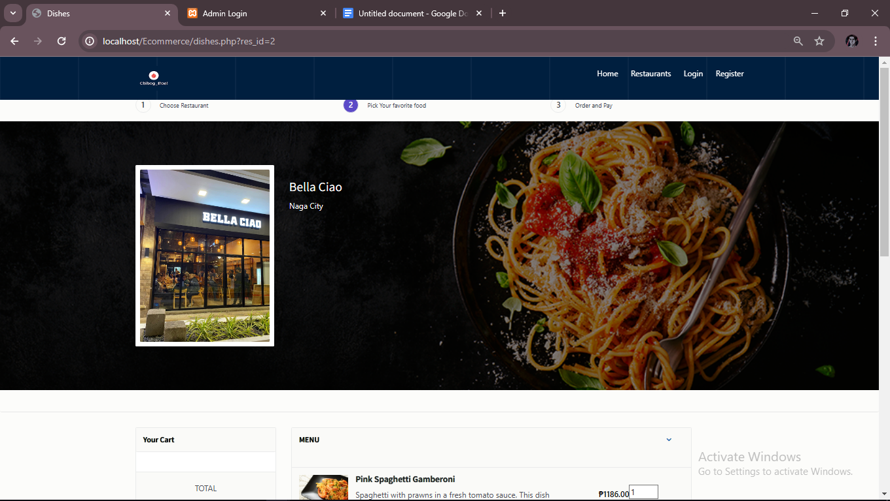

This is the example after you choose a restaurant or dishes it will redirect you now to the page where all the dishes on a restaurants is displayed so you can choose so more dishes on that restaurants.

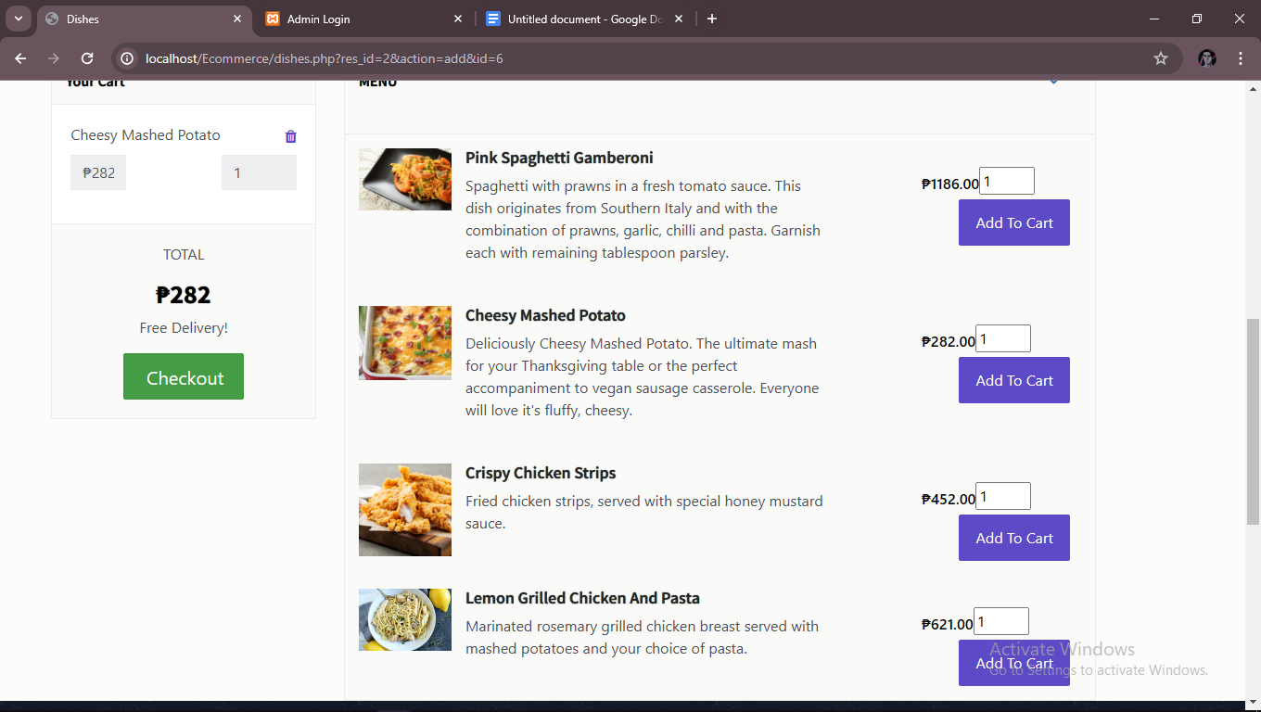

If you press the add to cart the dish is then added to the cart and if you choose another dish it adds up the value for you.

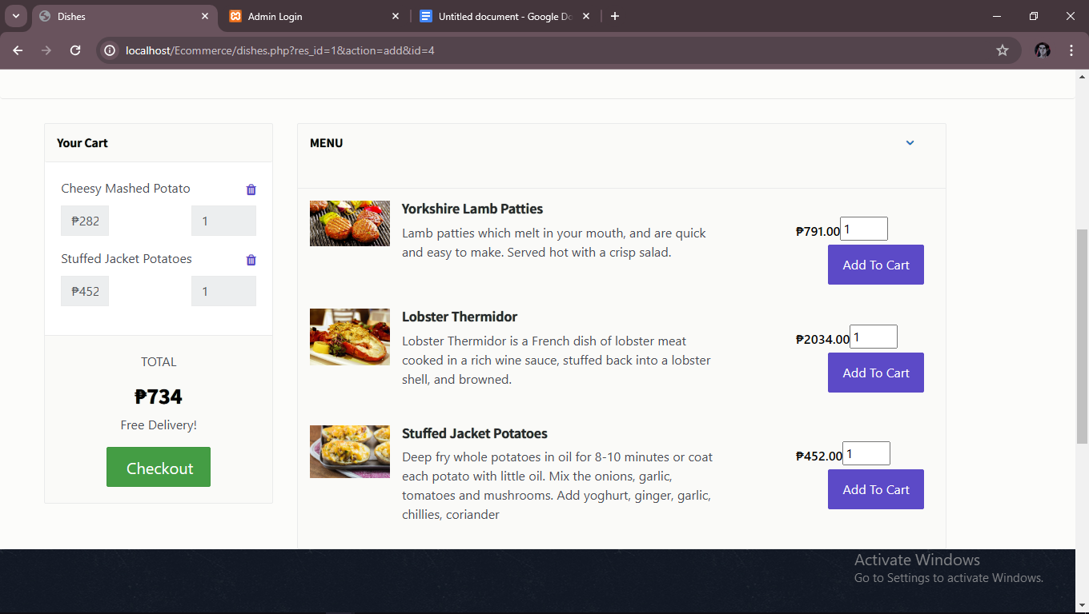this is the example i’ve choose one dish from italian restaurant and another from american restaurants and it adds up the amount of the dishes.

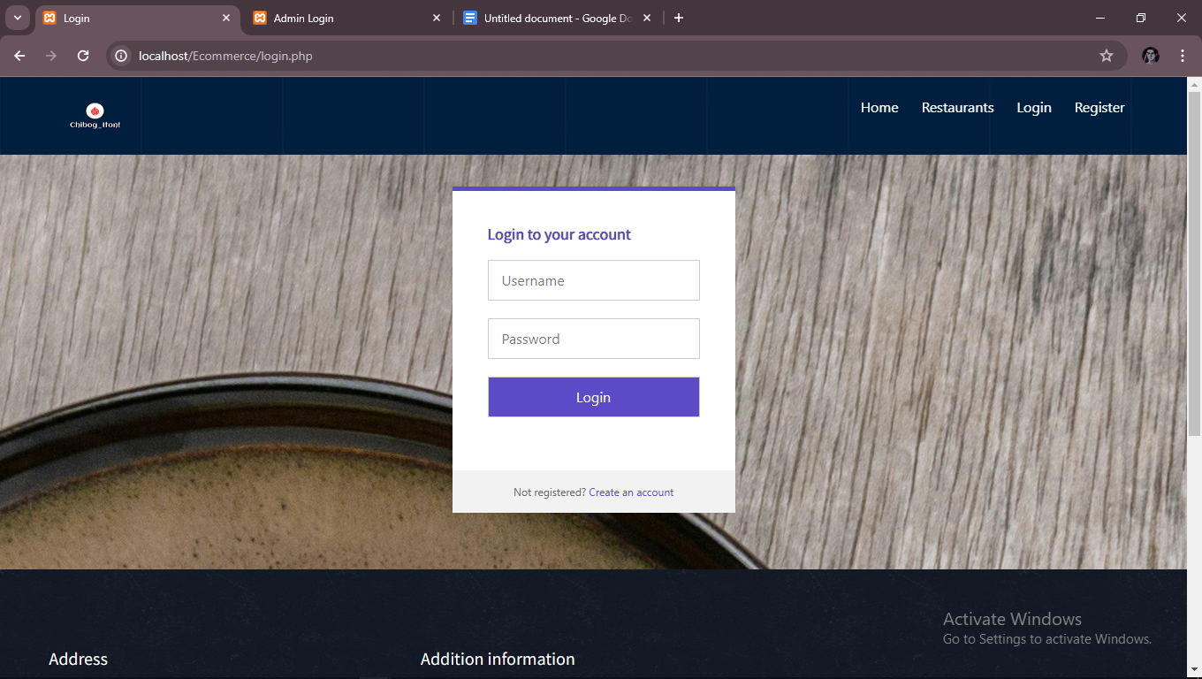when you press checkout if you don’t have an account or not logged it it will redirect you to the login page.

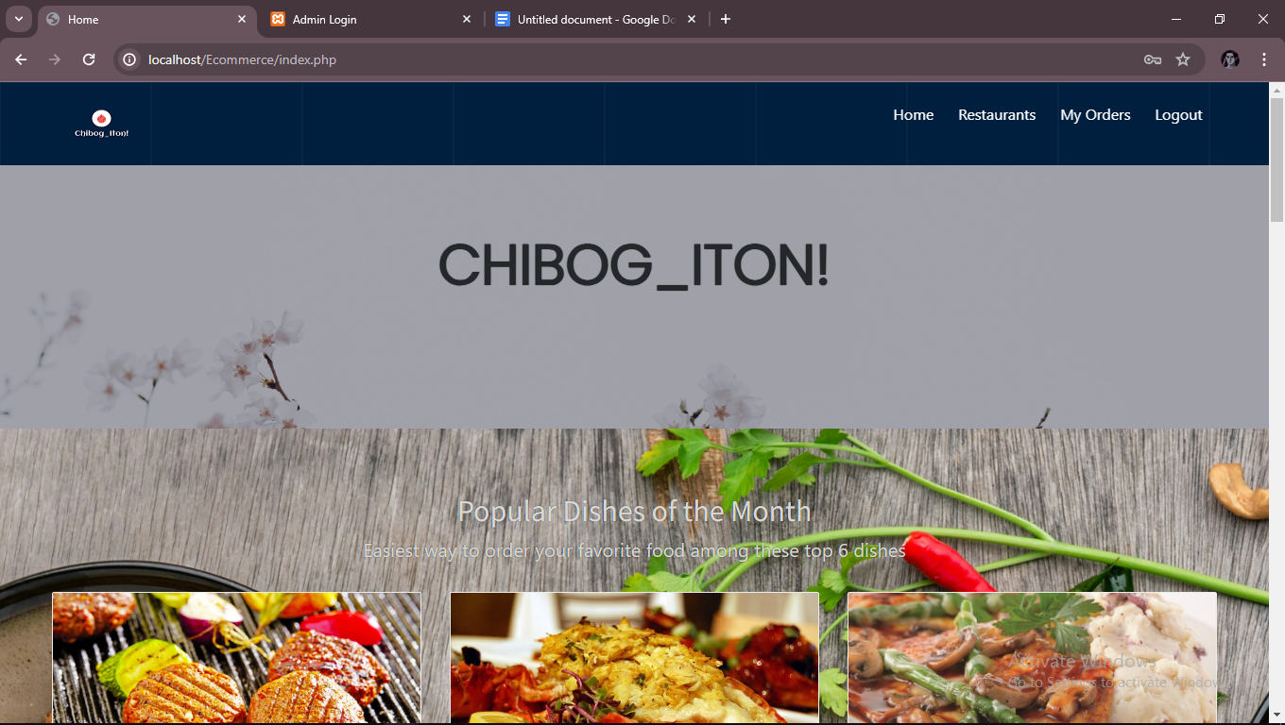after you logged in and created an account it will redirect you back to the homepage then you will notice at the top right corner it displays now the My Orders(Cart) and Logout once you see that means you are logged in and can proceed to checkout your order.

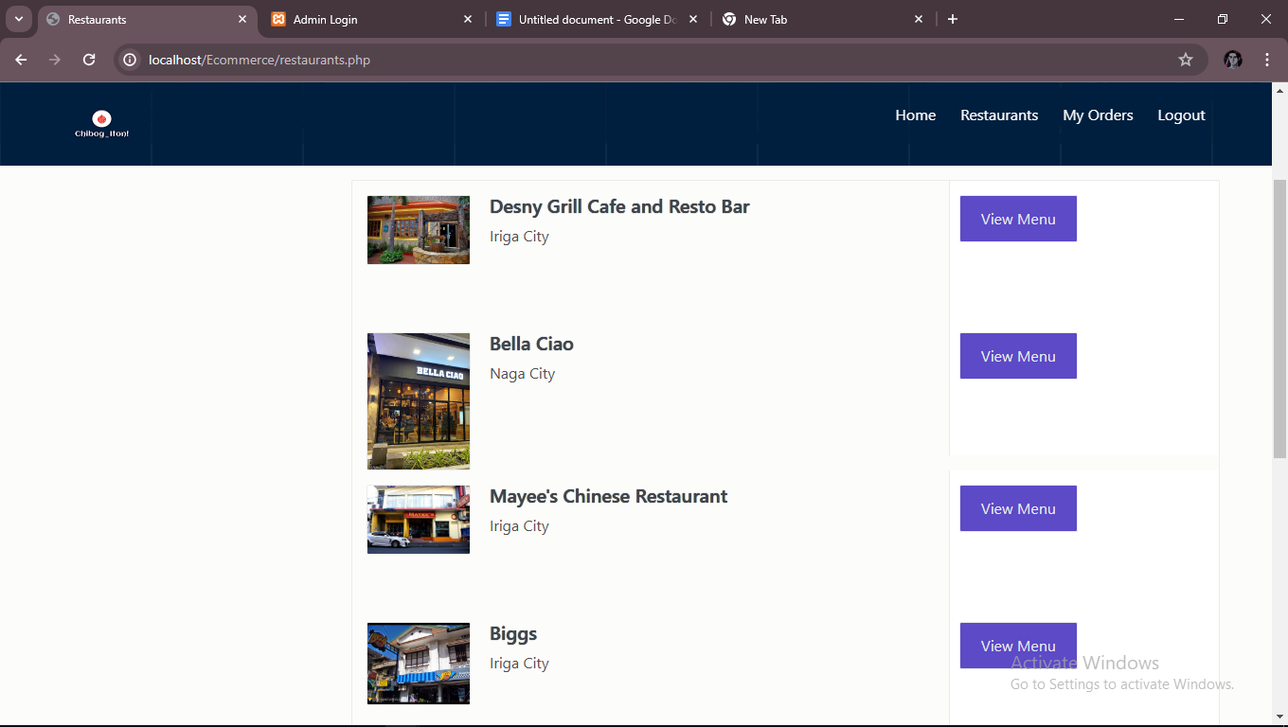To checkout you just simple need to go back to restaurants and click any restaurants to see the added dishes

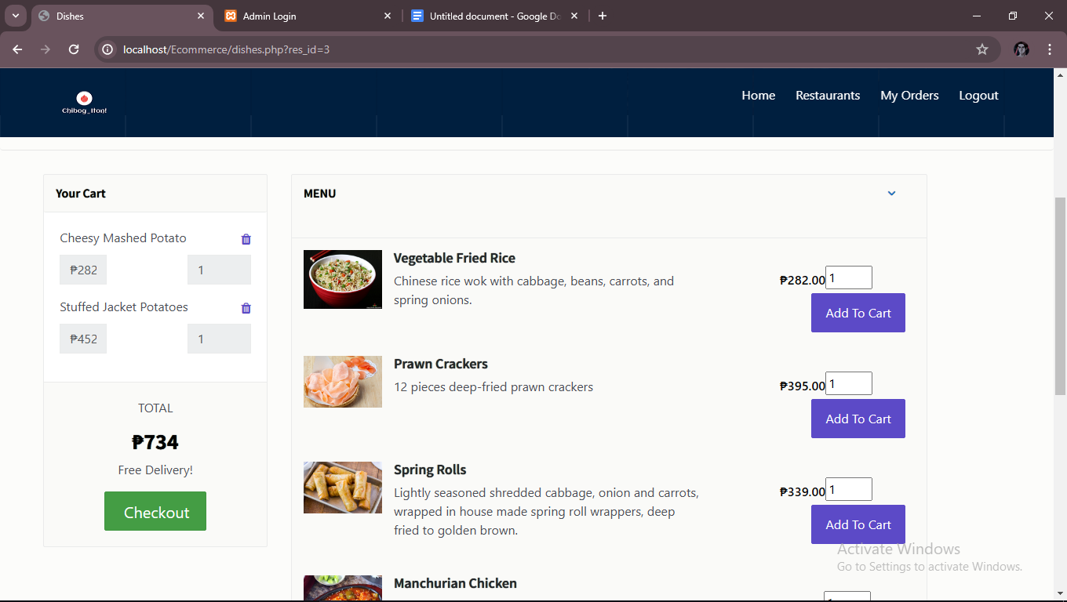

Here you will see the your cart you can delete what you added and after you click the checkout it will then redirect you now to the checkout page.

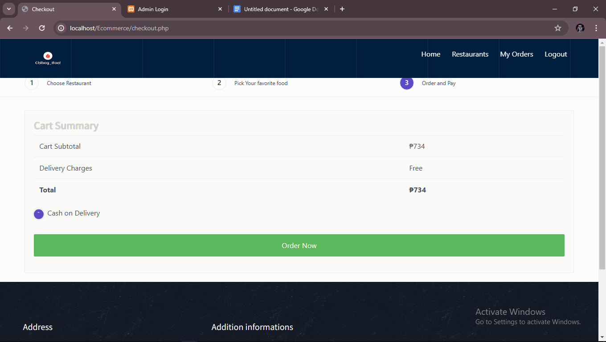here you can see the total of your order and currently we prioritize cash on delivery that is our only payment method.

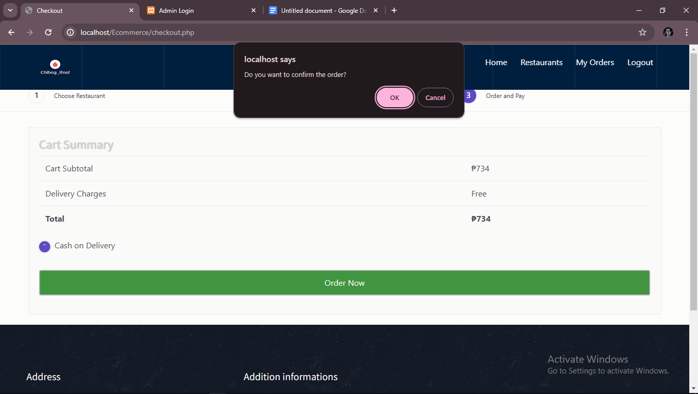after you press the order now button it a prompt popup will appear to make sure that you are sure to order it now once (ok) button is clicked the order is then now processed and the admin will see it.

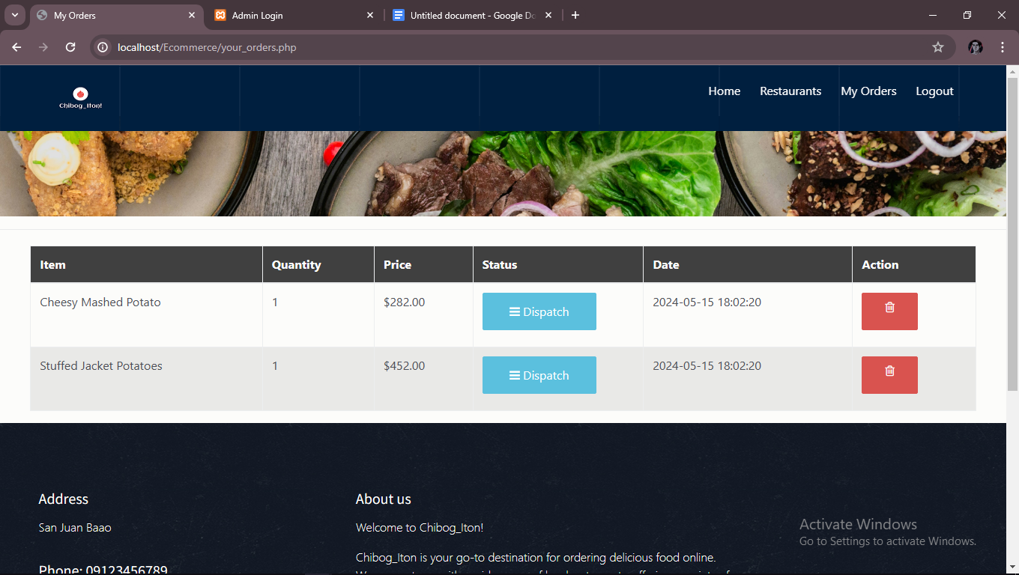

And lastly after you click ok it will then redirect you to the my order page. Here you can see the status of your order.

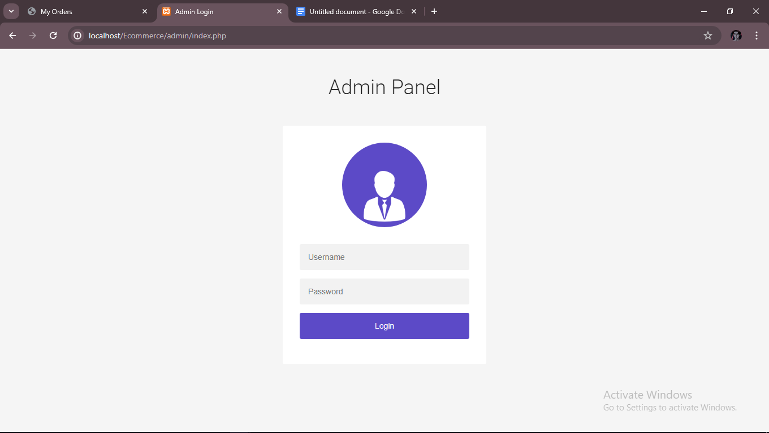in the admin page you are required to enter the username and password before you can view the inside of it currently the username and password is set to admin.

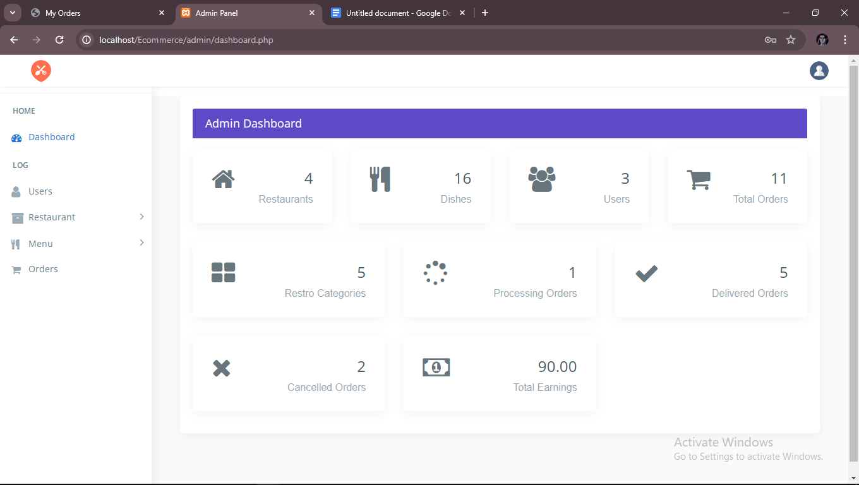

once logged in you will then be redirected to the dashboard here you can see important infos like your earnings, canceled orders, users, etc.

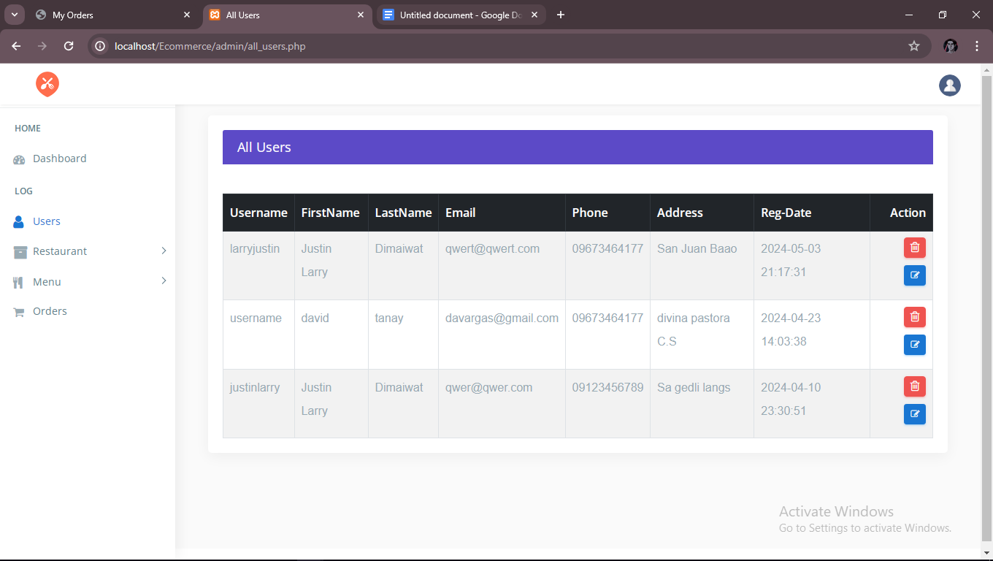in the users page you will see all of the users that registered to your ste and their info.

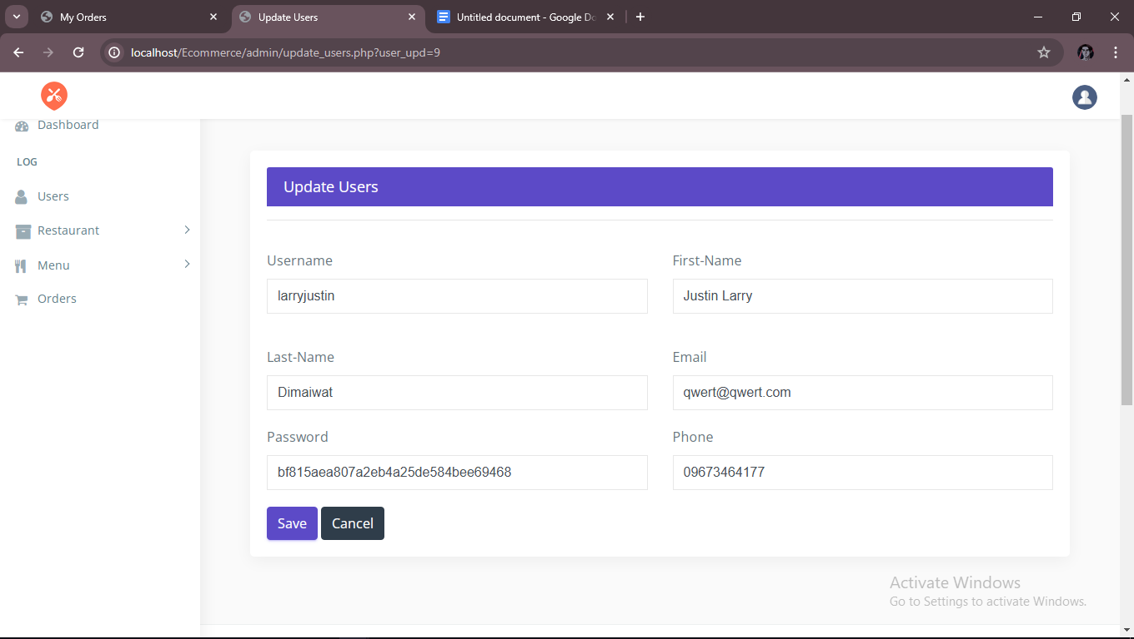you can edit their profile if they request for example and also you can delete their account.

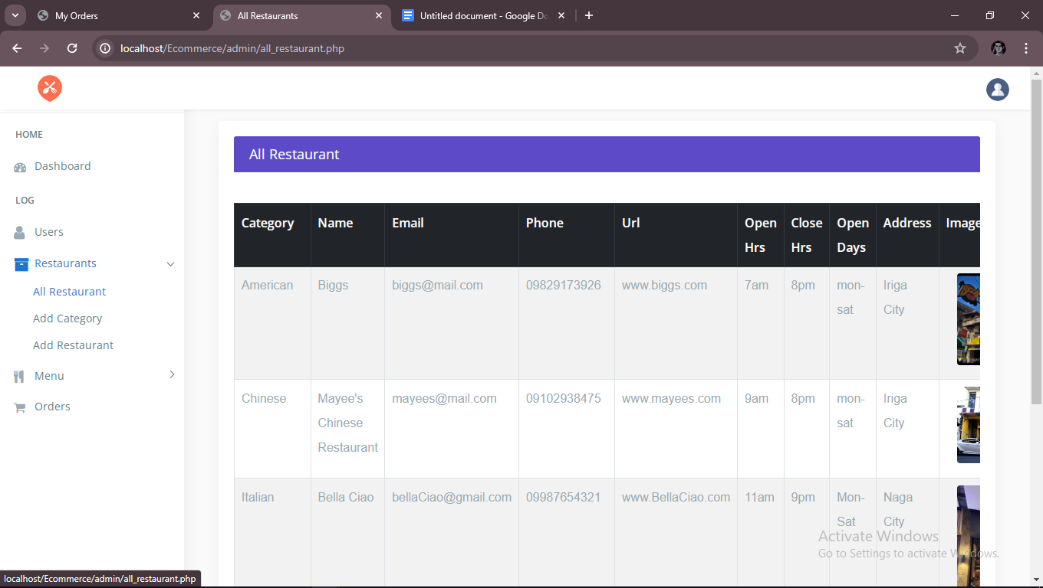in the restaurants you will see all the restaurants that you’ve added and their info. Just like the users you can delete and edit restaurants

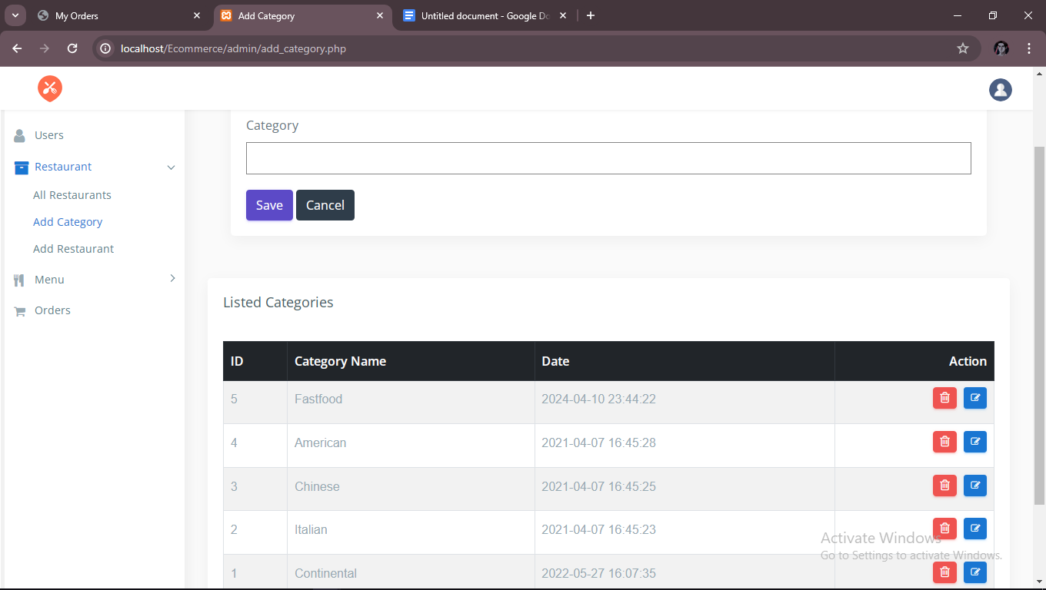you can add another category if you plan to collaborate with other restaurants.

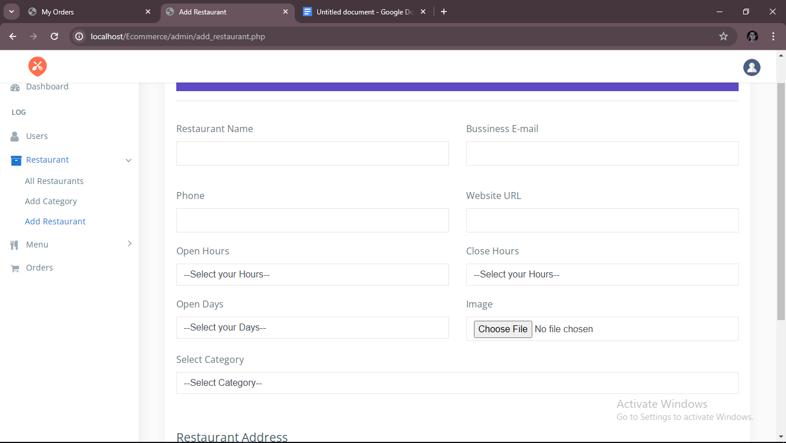and add a restaurants.

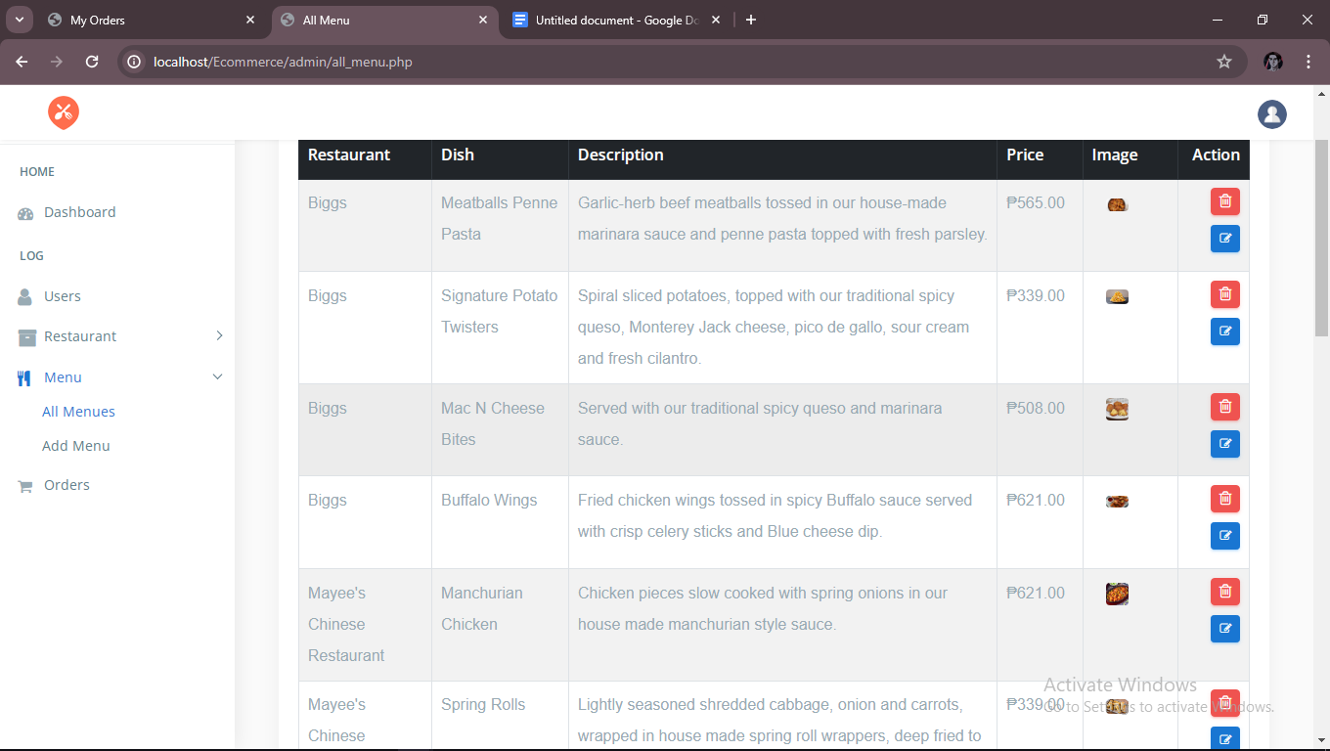in the menu tab you will see all the menus in all of the restaurants

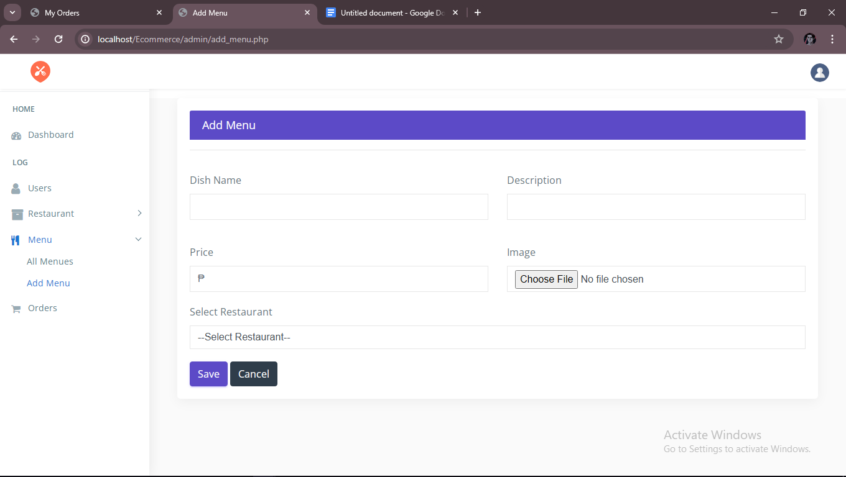and also you can add a new menu.

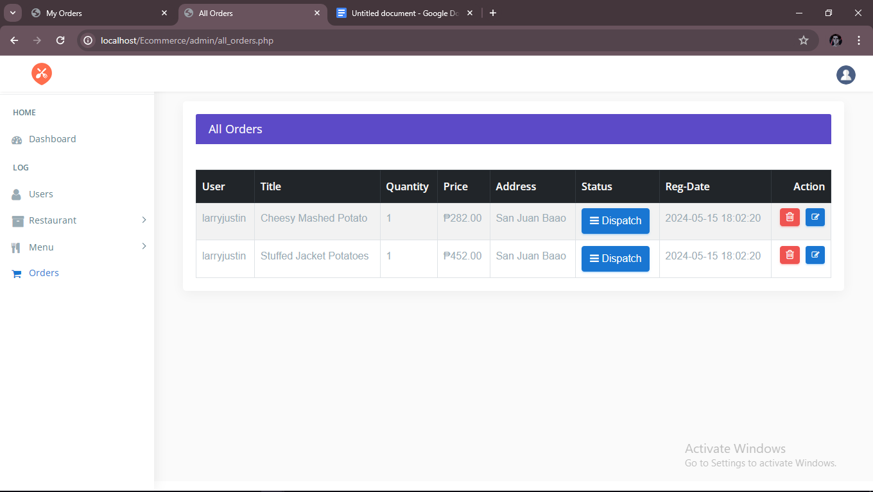and in the orders you will see and manage the orders of all the customers for now we manually add the status of the orders but in the future we will add a mobile app so that the delivery rider is the one that will updat ethe status of the orders.

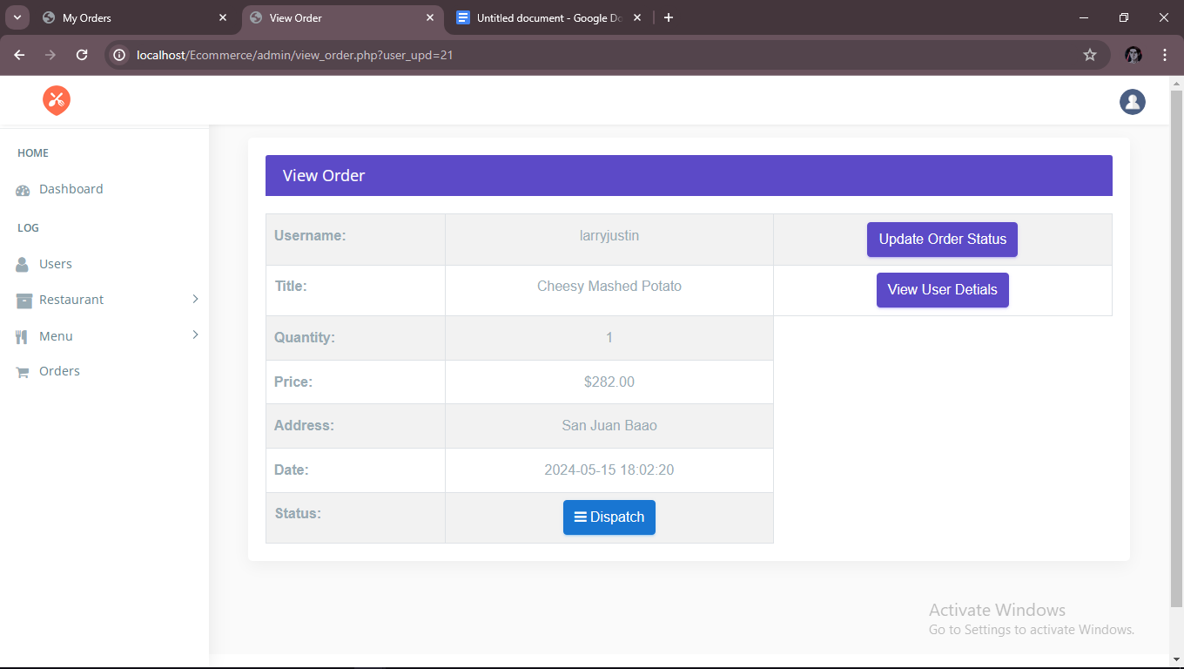here you can update the order status

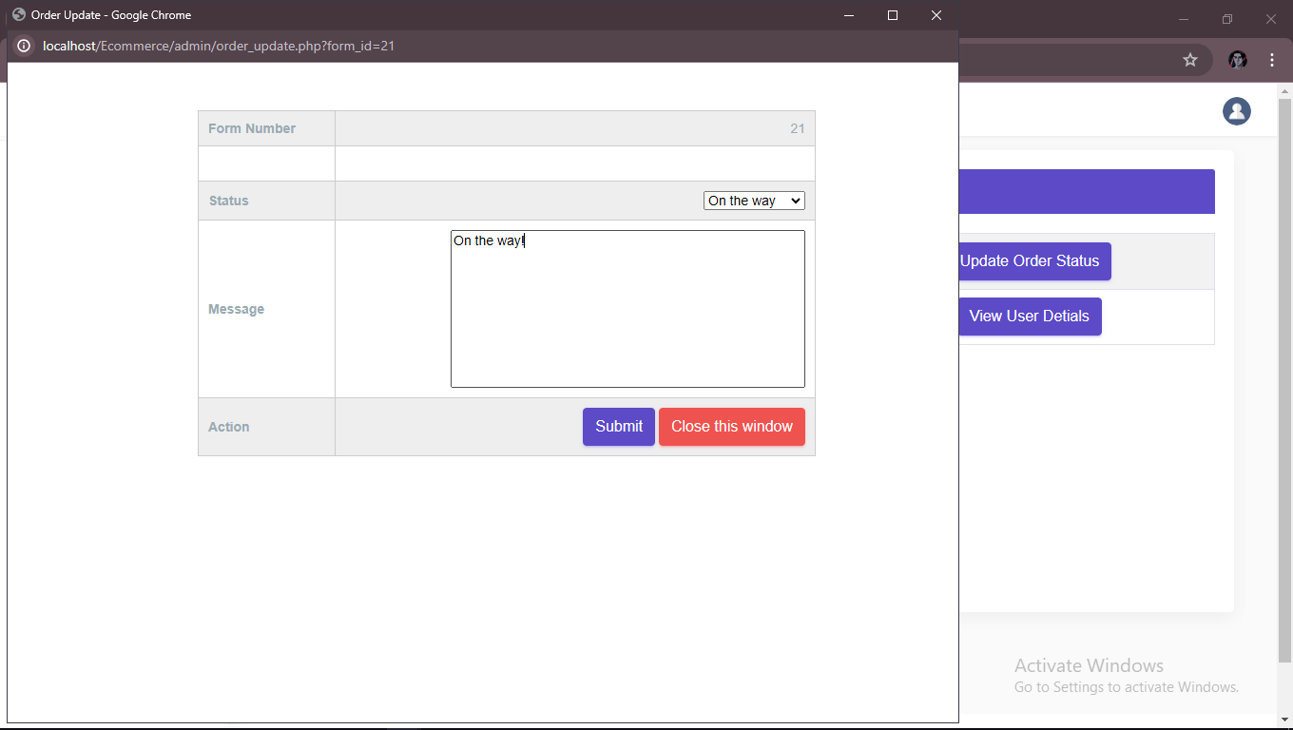once submit button is pressed the orderstatus is now updated

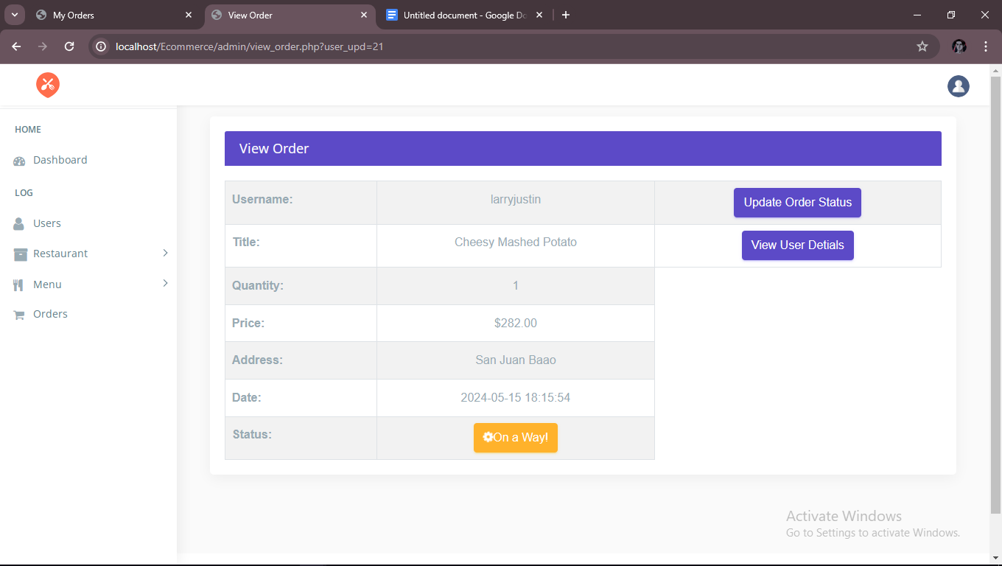

It indicates now that the order is on the way.

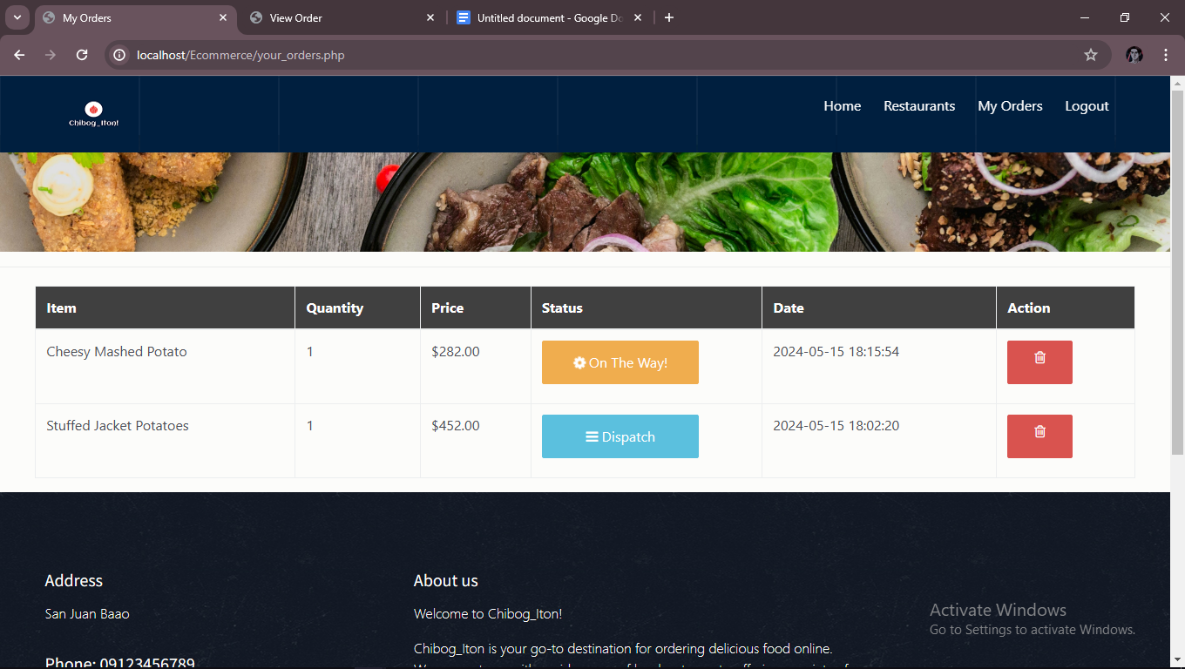and on the user the status can be seen also

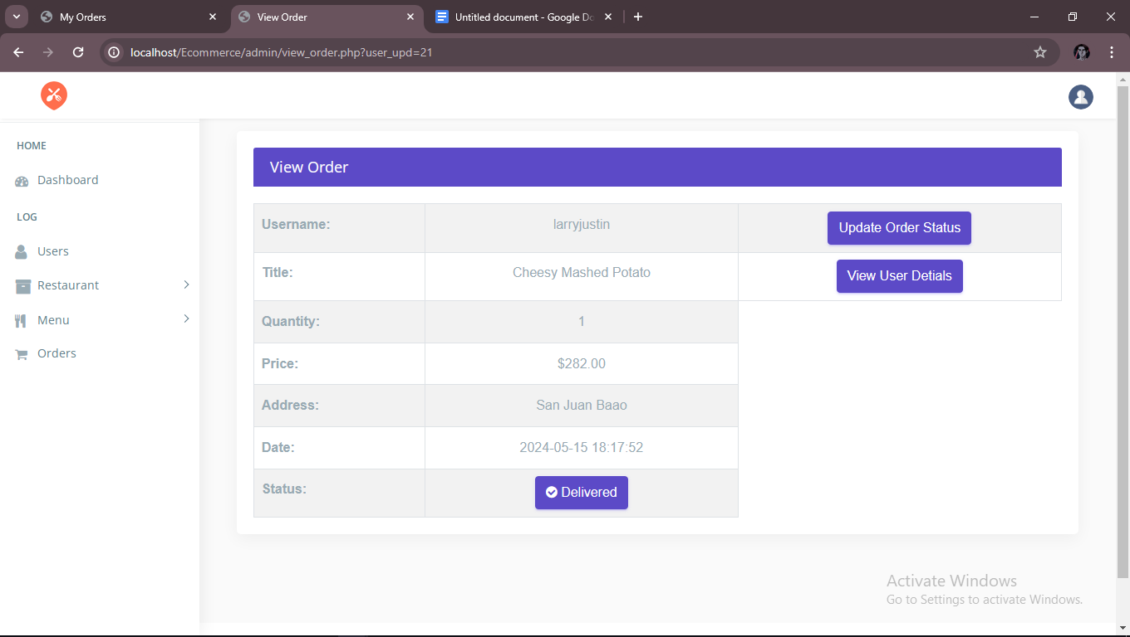then you can update it again for example the order is already delivered

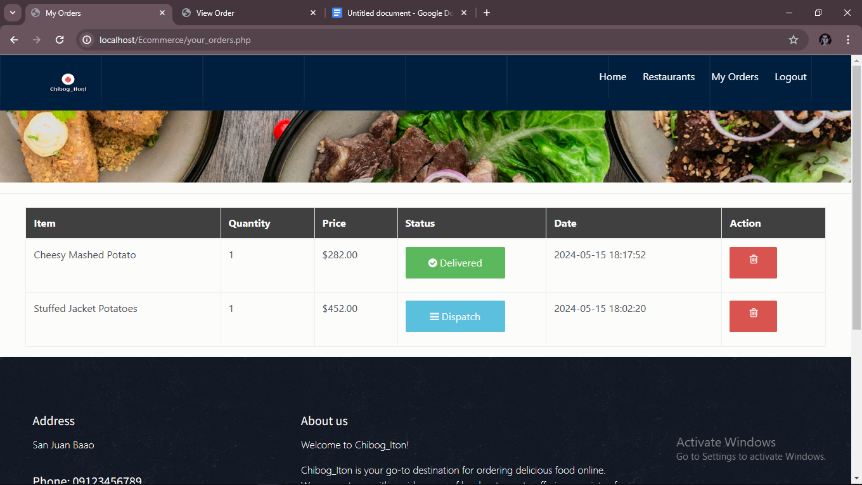then it will display also in the user side.